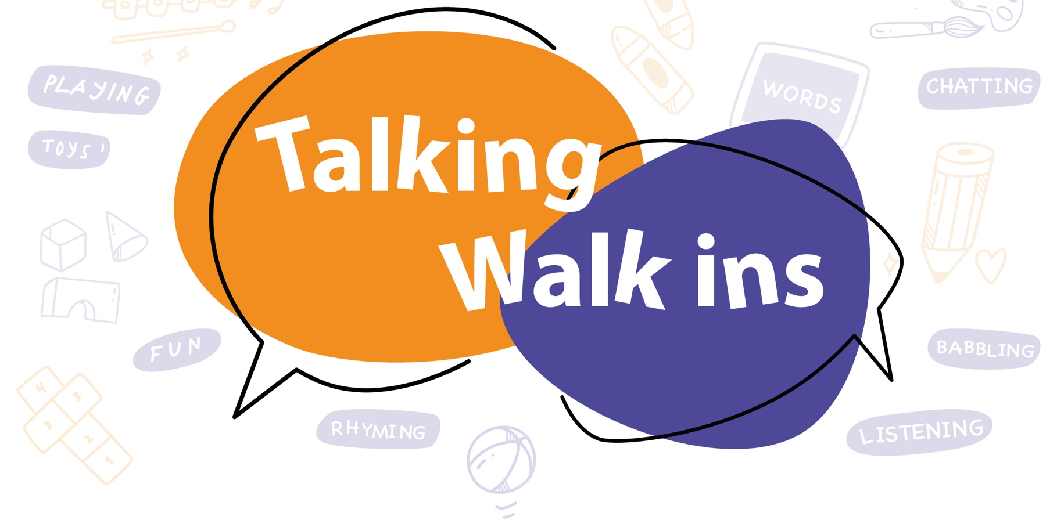

Ashford

Concerned about your pre-school child’s speech, language or communication skills?
Talking Walk-ins are play-based drop-in sessions where you can speak to a speech and language therapist
Just turn up – no need to book!

For residents living in Ashford with pre-school-aged children.
(The service will be coming to other parts of Kent).

Children’s Centre | Day/session
The Willow Children’s Centre, Brookfield Road, Ashford, Kent, TN23 4EY Tel: 03000 418800 | 1st Thurs of month Time: 1.30-3.45pm
Bluebells Children’s Centre, School Road, Hothfield, Ashford, Kent, TN26 1HA Tel: 03000 418300 | 2nd Weds of month Time: 9.30-11.45am
Waterside Children’s Centre, Turner Close, Ashford, Kent, TN24 0PQ Tel: 03000 418700 | 3rd Weds of month Time: 1.30-3.45pm
Sure Steps Children’s Centre, Belmont Road, Kennington, Ashford, Kent, TN24 9LS  Tel: 03000 418600 | 4th Weds of month Time: 1.30-3.45pm
Little Explorers Children’s Centre, Recreation Ground Road, Tenterden, Kent, TN30 6RA Tel: 03000 418400 | 5th Wednesday of the month  (when occurs) Time: 1.30-3.45pm
Talking Walk-ins provide you with advice or ideas to try at home. We may signpost you to other support or invite you to a follow-up with the speech and language therapy service.

They run in school holidays, but not on Bank Holidays or between Christmas and New Year. Check the Children’s Centre Facebook page for updates.

