Patient Feedback  Please visit the patient feedback link below for the easiest way to provide West Kent Health with feedback on your experience with the Post Covid Assessment, Support and Rehabilitation Service today.  https://westkentprimarycare.co.uk/contact-us/  I was very impressed with the app but also with the check ins from the covid nurses who were very helpful and friendly.  For me personally the telephone service was excellent, and I was happy with the support I was given.  My case manager was superb and I'm grateful that she was there, making contact. It was reassuring to know that someone was in the background who could be contacted when I had concerns.  Contact Us  West Kent Health Ltd  Hospice in the Weald, Maidstone Road, Pembury, Kent, TN2 4TA  01892 481821  westkenthealth.federation@nhs.net  www.westkentprimarycare.co.uk |  | West Kent Primary Care  West Kent Primary Care is a GP federation, formed with the vision of strengthening local General Practice in West Kent and providing a united approach to managing and supporting the opportunities identified in the local area. Following the commissioning of the Post Covid Assessment, Support and Rehabilitation Service, West Kent Primary Care are pleased to be able to provide a resource to GP practices in Kent and Medway regarding patients with suspected Long Covid. All GP practices throughout Kent and Medway are therefore encouraged to refer patients with suspected Long Covid into the service to assist in the assessment, support, guidance and provision of care. |  |  | Information for  Patients on  Post Covid Assessment, Support and Rehabilitation Service  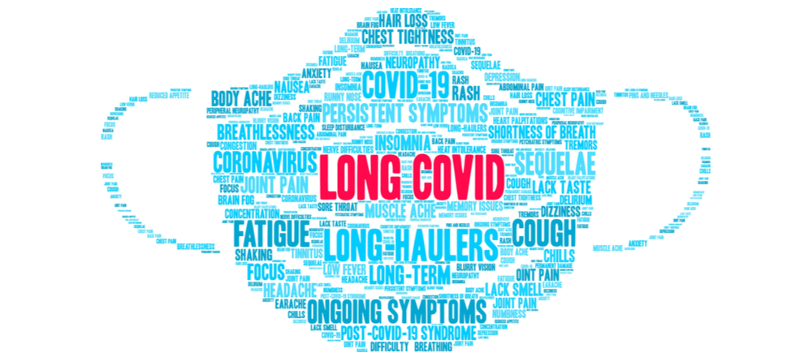
A brief background  Post Covid Assessment services were introduced throughout England to assess, advise, and guide individuals experiencing suspected post-covid syndrome (Long Covid). Historically there has only been the provision of a virtual service, however due to recent changes to NHS England guidance, our service has been developed to enable delivery of face-to-face clinical assessments and rehabilitation services.  Following an initial consultation and multi-disciplinary team discussion, and dependent on individual need, the following services have been established within Kent and Medway and may be advised:  - Self-management via Living With app  - Social prescribing  - Pulmonary rehabilitation or dysfunctional breathing support  - Psychological support  - Fatigue Support  - Further diagnostic requests  - Onward specialist referral |  | Where?  Following acceptance of the referral from your GP, an invite will be sent for an initial consultation with the PCAS team. The offer will be made for either a video or telephone call, depending on your preference. At the same time as the consultation invite, a further invite will be sent for enrolment onto the Living With app. This will allow for completion of specific assessments prior to your consultation to assist the clinicians both during the initial assessment and at the multi-disciplinary meetings in creating an individual treatment plan.  When?  The service runs Monday to Friday (excluding bank holidays), from 9am-5pm.  Who?  Although the initial consultations are undertaken by an experienced nursing team, the PCASR service is led by senior GPs, and supported by Occupational Therapists, Mental Health professionals and Neuropsychologists on a constant basis. |  |  | How to access?  If you have any concerns relating to your health following Covid-19, then you would need to be referred to the service via your GP following a face-to-face assessment and investigations.  Patient feedback  In addition to feedback surveys being sent at specific times throughout the patient’s journey, we would like to hear from you if you have any further comments about your experience with the Post Covid Assessment, Support and Rehabilitation Service.  Your feedback can help us ensure that the service provision can be addressed, and we can continue to improve for every patient registered within Kent and Medway.  Please find details on how to do this over the page.

